Tribo-dynamic Analysis of Roller Bearings for Electric and Hybrid-Electric Automotive Powertrains

Harry Questa*[1], Mahdi Mohammadpour1, Stephanos Theodossiades1, Stephen R. Bewsher2, Günter Offner2

Keywords: Ultra-High-Speed, Roller Bearings, NVH, Durability, Efficiency, Hybrid Electric Powertrain

# Introduction

As legislations drive powertrain development, the required efficiency cannot be achieved through conventional engines. Many automotive manufacturers are conducting research into Hybrid and Electric Vehicles. The trend towards ultra-high speed and low load motors introduces new challenges regarding NVH (Noise, Vibration and Harshness) and tribology of interacting conjunctions. The compact, lightweight and efficient motors operate under significantly different working conditions and are subject to different underlying physics; such as regime of lubrication, dynamic response and magneto-mechanical interactions.

Roller bearings are critical components of these motors. Under light load and high speed, the elastohydrodynamic (EHL) contacts of these bearings significantly change their tribological behaviour. These bearings should also operate under a wide range of conditions and are subject to many NVH phenomena. To accurately predict the behaviour of bearings, novel experimentally validated component and system level models need to be developed.

Dynamic analyses that assume dry contacts are not valid in high-speed applications due to the magnified role of EHL film. Hence, a combination of dynamic and contact mechanics is required. Computationally, these analyses are time consuming. Alternatively, the dynamic response of the outer ring and shaft can be obtained experimentally. By superimposing the displacements of these two components, the relative displacement at the bearing centre can be found. These values can then be incorporated into an explicit quasi-dynamic tribological model [1]. Test rigs in current literature consist of static [2] or low shaft rotational speeds.

In this study, a component level test rig has been built to allow for 2 kN sinusoidal (20-4000 Hz) radial loading of a shaft; synchronized with the shaft’s rotary frequency under high-speed (18,000 rpm) transient conditions. Boundary conditions required for a numerical tribological analysis, including displacement of the bearing centre, have been ascertained from experimental test results.

# Results

Figure 1 shows the time history of the shaft eccentricity following signal processing for a SKF6205 bearing relative to the outer race, obtained from a speed sweep of 1-18000 rpm. The radial excitation is applied using an electromagnetic shaker (20-1500 Hz).

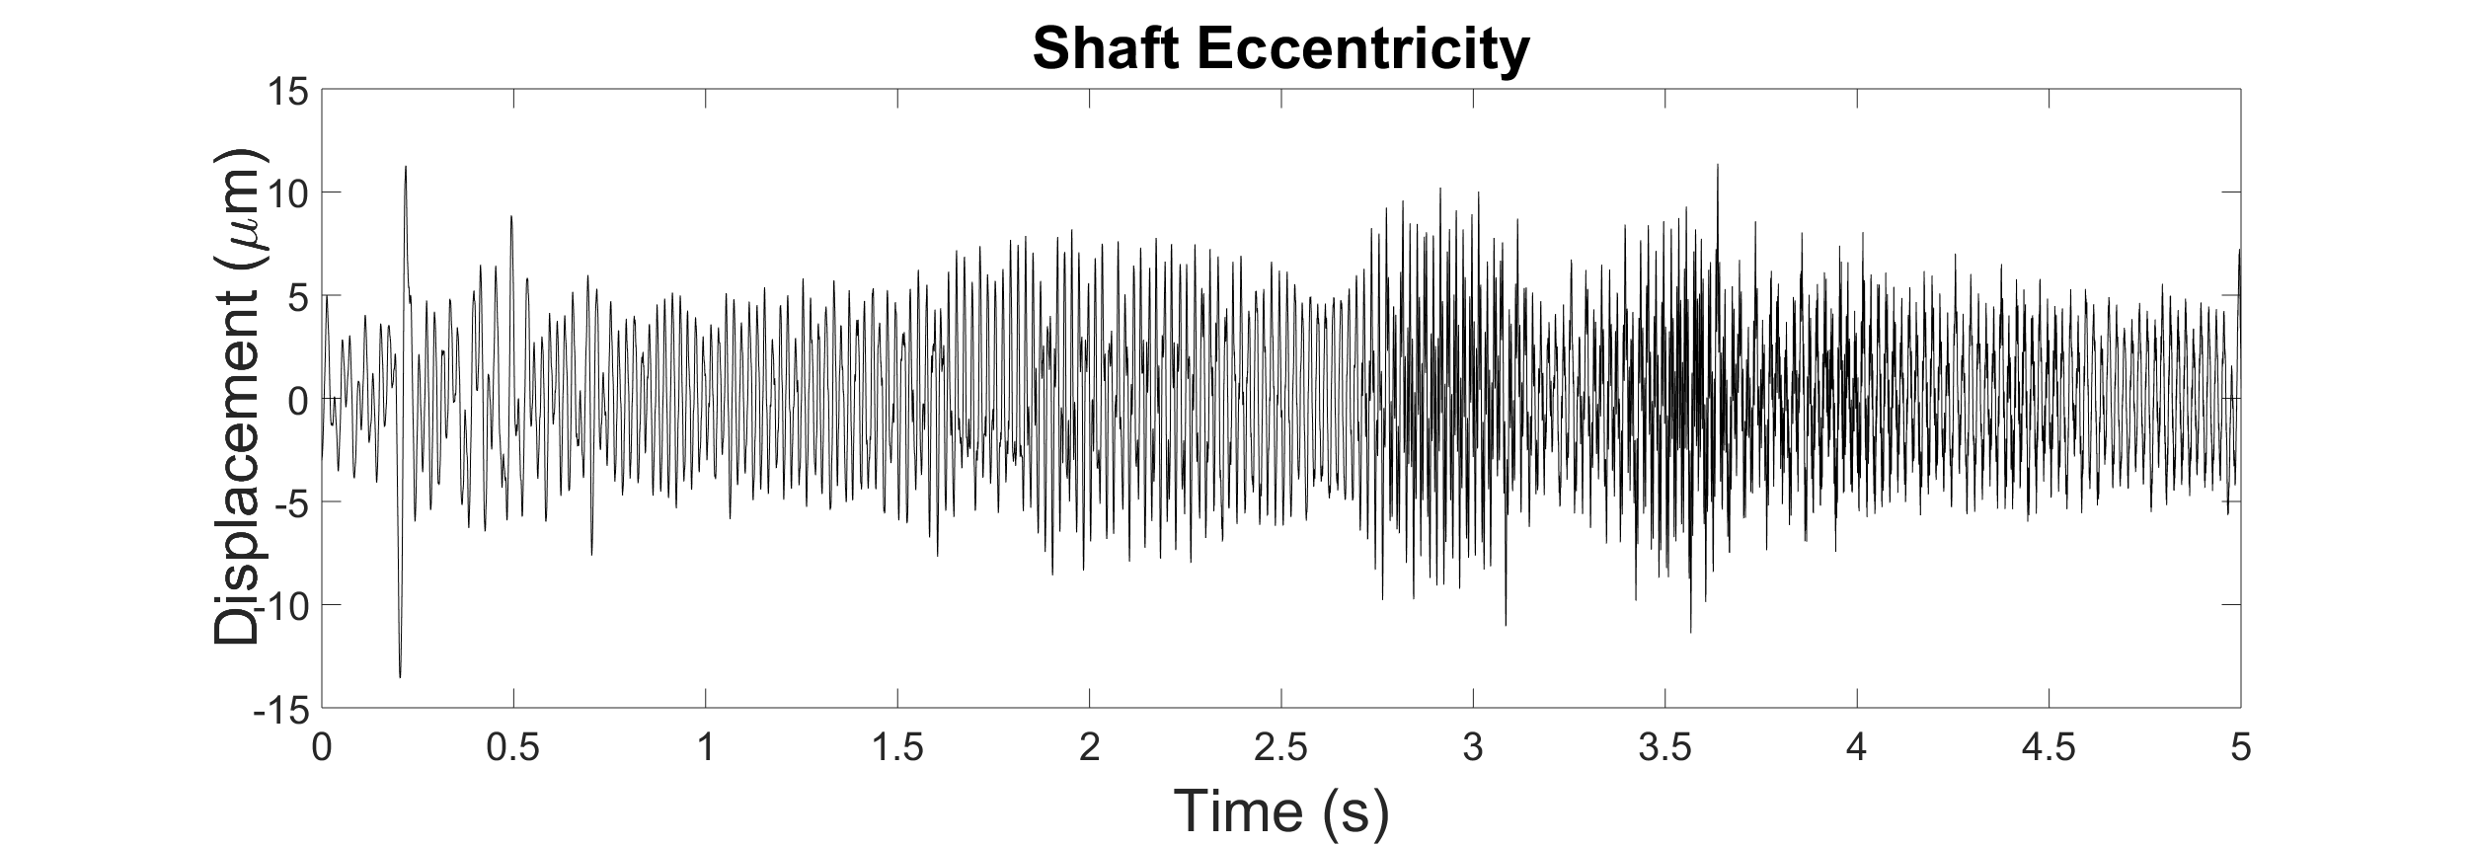

Figure 1: Time history of the shaft eccentricity

Figure 2 shows the numerically modelled [1] variation of load and corresponding film thickness for a single roller under given conditions. Results show that the concept of experimentally obtained boundary conditions for the tribological investigations under high speed conditions can be successfully applied. It is also revealed that the film thickness significantly changes from 0.1 to 2μm

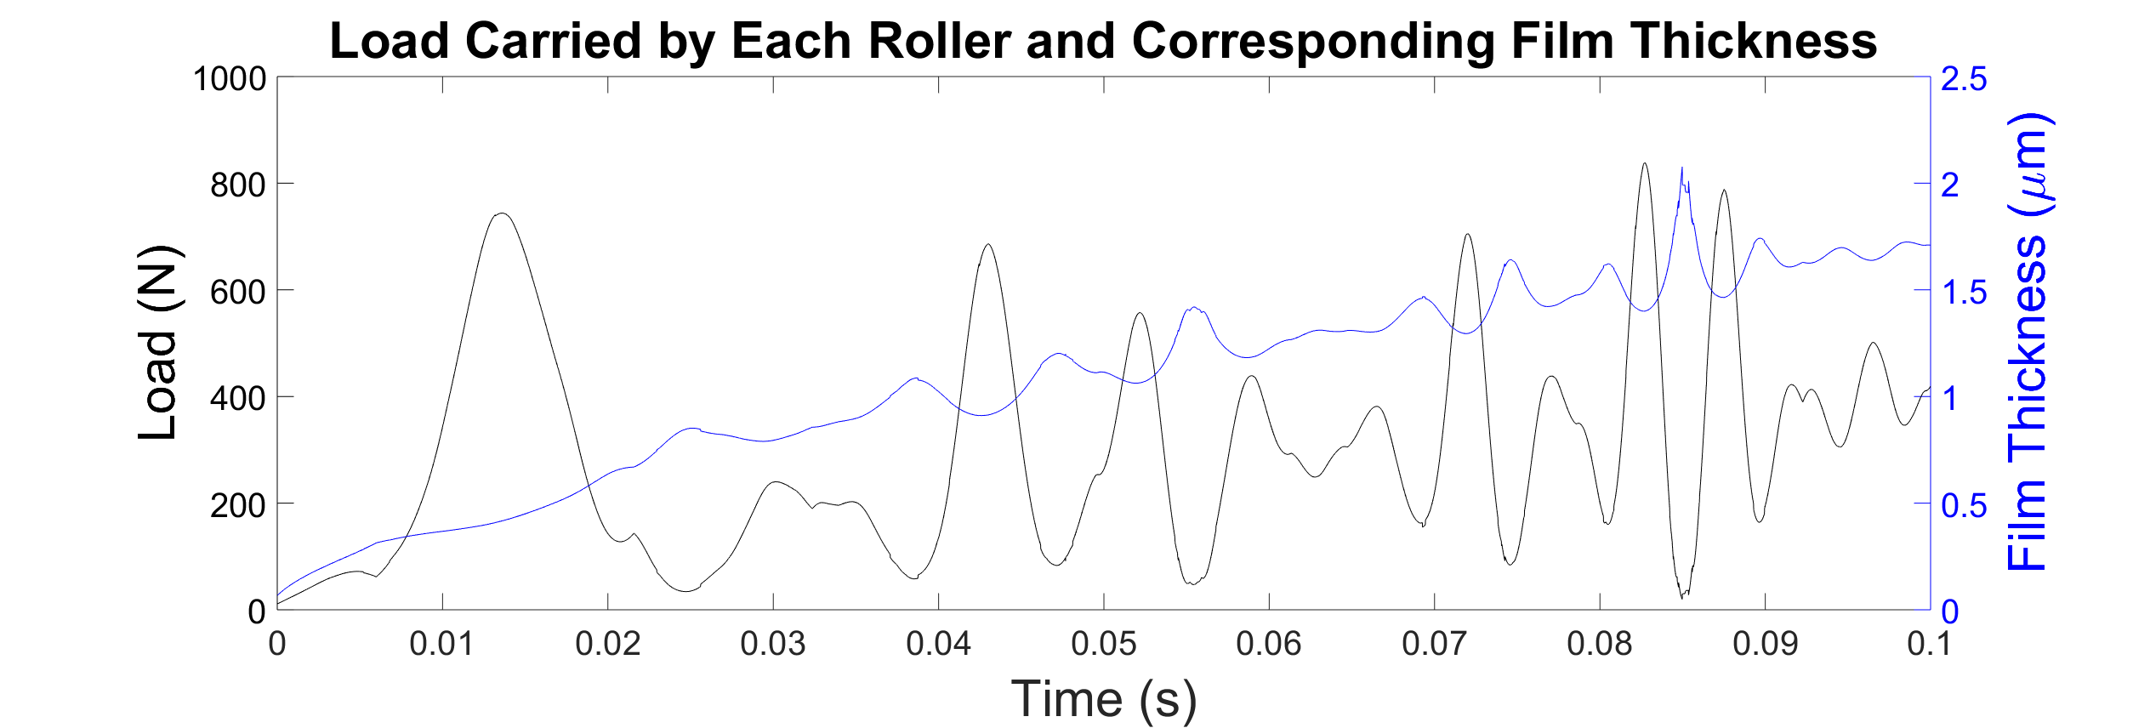

Figure 2: EHL film thickness

# References

[1] Mohammadpour M, *et al*. Roller bearing dynamics under transient thermal mixed non-Newtonian elastohydrodynamic regime of lubrication. Proc. IMechE, Part K: J. Multi-body Dynamics, 2015; 229 (4): 407–423.

[2] Lim TC, et al. Vibration transmission through rolling element bearings, part III: System studies. JSV, 1991; 151 (1).

1. * Corresponding author: Harry Questa, [H.Questa-15@student.lboro.ac.uk](mailto:H.Questa-15@student.lboro.ac.uk)

   Wolfson School of Mechanical, Electrical and Manufacturing Engineering, Loughborough University, Loughborough UK

   2 AVL List GmbH, Hans-List-Platz 1, 8020 Graz, Austria